Training Session – BOM, MR, DP Import from Saved Versions

Overview.....................................................................................................................................1

Access from MR widgets.............................................................................................................1

Saved version........................................................................................................................2

Importing data from saved version.......................................................................................3

Working Process...................................................................................................................3

Access from BOM widgets.........................................................................................................4

Saved version.......................................................................................................................5

Importing data from saved version.......................................................................................5

Working Process..................................................................................................................6

Access from DP objects............................................................................................................6

Saved version......................................................................................................................7

Importing data from saved version......................................................................................7

Working Process..................................................................................................................8

**Overview**

In the pop Import from saved version is used to contain the historical data of MR, BOM, DP objects after importing new objects in existing version. This functionality is use to contains the record of previously existing data. If users change record data in the existing version and want to update the data which are available in saved version then we can achieved by using the import from saved version functionality.

Ex- If users import first 50 object and second 40 object then system create a version of 50 objects in saved version popup. If users change data in 50 objects and users want to update the data then import from saved version is use.

Access from MR widgets

When users need to import this data using the import from saved versions, click on the import from excel at the top of the grid.

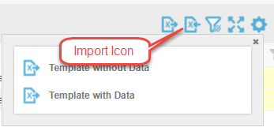

After clicking the import icon the popup opens and shows the import from the saved version link button.

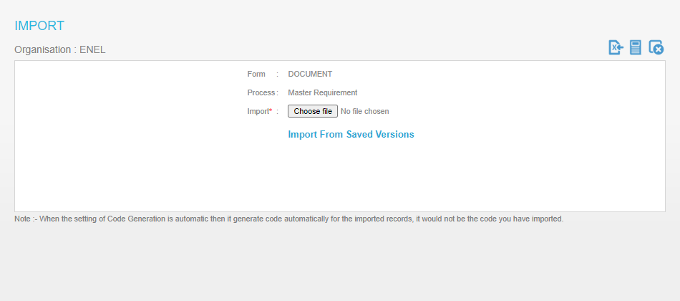

When users click on import from saved version button then popup open with the saved version record.

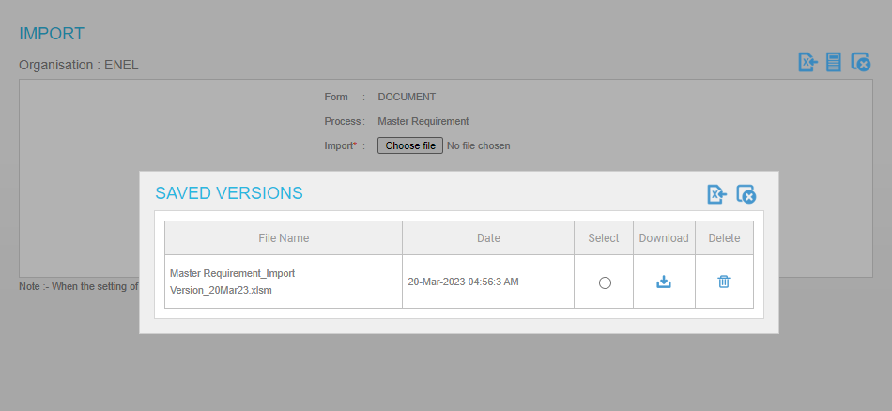

In the saved version we contain the copy of the existing record after importing the new imported data. In every time when we import the data then the system creates a version of the previous record. In the saved version maximum 5 files are shown.

Saved Version

File name- The columns shows the excel file name.

Date – The column shows the date and time of the version creation.

Select- The check box is use for select the version which need to import.

Download. When users click the download button then file download in the system.

Delete – When users click on delete button then the file delete from the saved version

Importing data from saved version

When users select the checkbox in select column and click on import excel button then the system show alert popup to confirm the import the file.

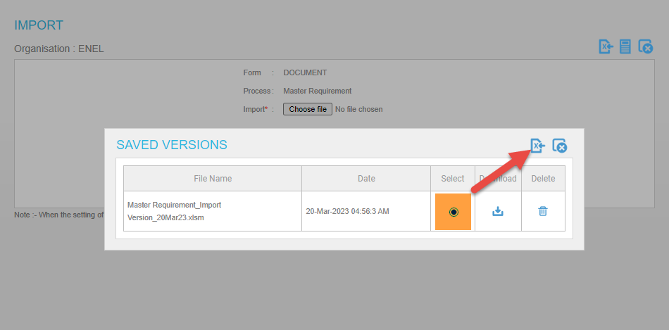

After confirmation of users to import the data from saved version then alert message to show the import of excel file will continue in background. When users click on Ok then popup close and data importd in background.

**Working Process**

When users import 50 MR objects using import from excel the system create 50 BOM objects automatically. After this users import 100 MR object then system create a version data of 50 MR in saved version popup. When users update any record in 50 MR objects and save and import from the saved version then records are updated which is saved in version data.

**Access from BOM widgets**

When users need to import this data using the import from saved versions, click on the import from excel at the top of the grid.



After clicking the import icon the popup opens and shows the import from the saved version link button.

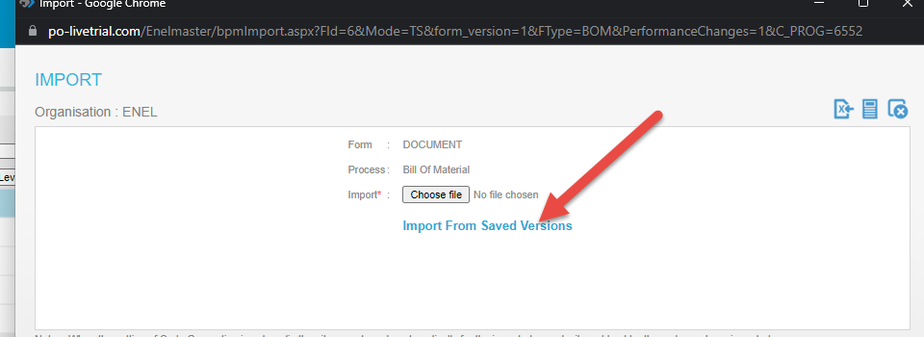

When users click on import from saved version button then popup open with the saved version record.

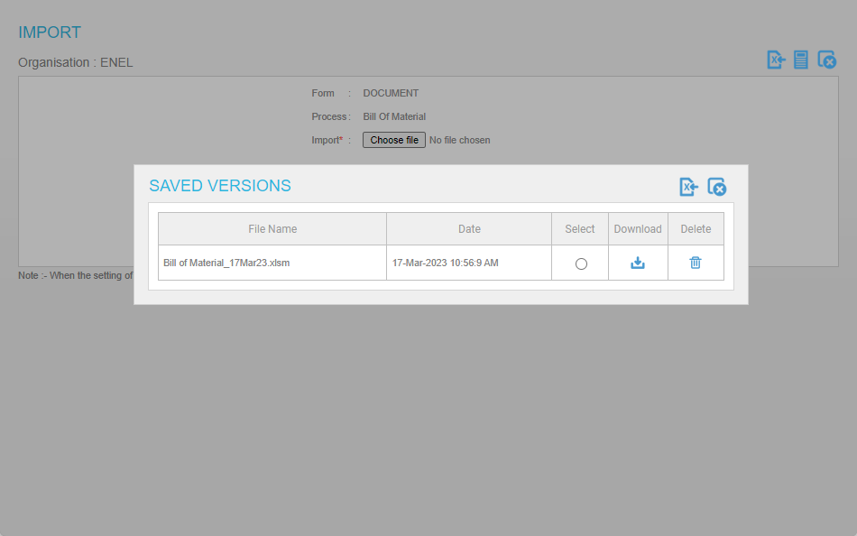

In the saved version we contain the copy of the existing record after importing the new imported data. In every time when we import the data then the system creates a version of the previous record. In the saved version maximum 5 files are shown.

Saved Version

File name- The columns shows the excel file name.

Date – The column shows the date and time of the version creation.

Select- The check box is use for select the version which need to import.

Download. When users click the download button then file download in the system.

Delete – When users click on delete button then the file delete from the saved version.

Importing data from saved version

When users select the checkbox in select column and click on import excel button then the system show alert popup to confirm the import the file.



Working Process

When users import 50 BOM objects using import from excel the system creates 50 MR objects automatically. After this users import 100 BOM objects then the system creates a version data of 50 BOM in the saved version popup. When users update any record in 50 BOM objects and save and import from the saved version then records are updated which is saved in version data.

Access From DP widgets

When users need to import this data using the import from saved versions, click on the import from excel at the top of the grid.



After clicking the import icon the popup opens and shows the import from the saved version link button.

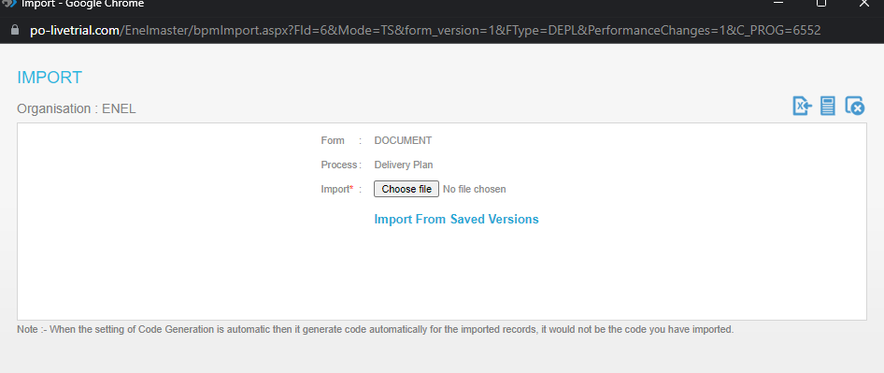

When users click on import from saved version button then popup open with the saved version record.

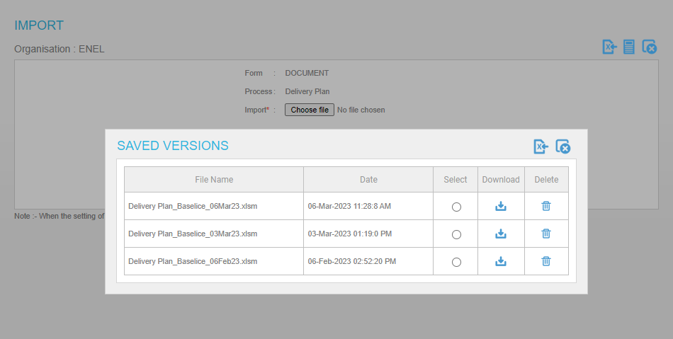

In the saved version we contain the copy of the existing record after importing the new imported data. In every time when we import the data then the system creates a version of the previous record. In the saved version maximum 5 files are shown.

Saved Version

File name- The columns shows the excel file name.

Date – The column shows the date and time of the version creation.

Select- The check box is use for select the version which need to import.

Download. When users click the download button then file download in the system.

Delete – When users click on delete button then the file delete from the saved version

Importing data from saved version

When users select the checkbox in select column and click on import excel button then the system show alert popup to confirm the import the file.

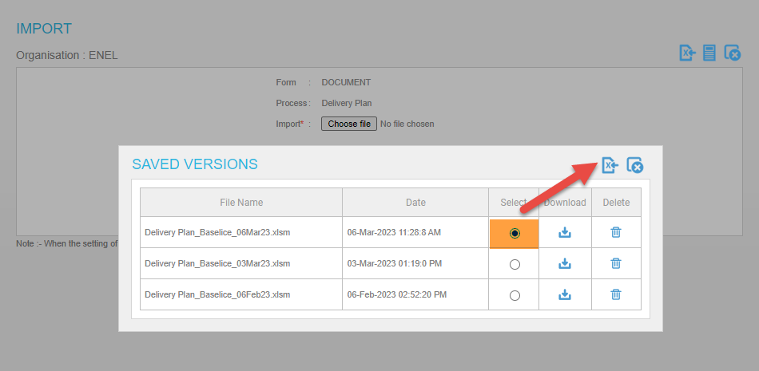

After confirmation of users to import the data from saved version then alert message to show the import of excel file will continue in background. When users click on Ok then popup close and data importd in background.

**Working Process**

When users import 50 DP objects using import from excel the system creates 50 BOM objects automatically. After this users import 100 BOM DP then the system creates a version data of 50 DP in the saved version popup. When users update any record in 50 DP objects and save and import from the saved version then records are updated which is saved in version data.